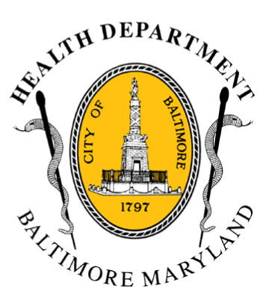

BCHD PRESS RELEASE
Baltimore City Health Department
1001 E. Fayette Street • Baltimore, Maryland 21202
Stephanie Rawlings-Blake, Mayor
Leana Wen, M.D., Commissioner of Health

FOR IMMEDIATE RELEASE

Media Contact: Michael Schwartzberg, PIO
O: (443) 984-2623 C: (443) 462-7939 E: michael.schwartzberg@baltimorecity.gov
Baltimore City First Jurisdiction In Maryland
To Mandate Naloxone Training For Drug Court Participants

Health Commissioner Doing First Courtroom Training Of Life-Saving Antidote Thursday Morning

BALTIMORE, MD (August 13, 2015) – Beginning today, in an effort spearheaded by Baltimore City Health Commissioner Dr. Leana Wen, the Baltimore City Adult Drug Treatment Court (DTC) will be the first in Maryland to train participants on the use of naloxone while they are in court.

Dr. Wen will launch the program this morning at 9:30 a.m. for approximately 30 DTC participants prior to the start of the court docket. Participants will also receive a prescription for naloxone, the life-saving drug that prevents overdoses from opioid drugs such as heroin, which can be filled at any pharmacy.

“Overdose deaths are a public health emergency,” said Dr. Wen. “Last year, more people died from overdose than died from homicide. The first step to recovery is staying alive. We need to get life-saving naloxone into the hands of people most at risk.”

Individuals with a primary drug-related criminal offense are selected to participate in DTC as an alternative to more traditional legal settings. The participants receive close supervision while participating in drug treatment programs, in addition to academic and vocational skill development. Every year, 300 people participate in Baltimore’s DTC.

“This is an important opportunity to provide training at a crucial time for DTC participants,” added Dr Wen. “Addiction is a disease. As with any disease, people can relapse. If they do, naloxone can save their life.”
- more -
2-2-2

"The Circuit Court for Baltimore City recognizes the importance of supporting the Health Department's major outreach program to reduce the increasing number of deaths from drug overdoses,” said Judge Ellen M. Heller (ret.), Circuit Court for Baltimore City, one of two-judges who preside over Baltimore’s Adult DTC. “By affording an opportunity to train the participants of our drug courts on how to get and give naloxone, the Court is definitely helping to save lives.”

In July, Mayor Stephanie Rawlings-Blake and Dr. Wen released the Mayor’s Heroin Treatment and Prevention Task Force report, calling for 10 bold steps to attack the city’s epidemic of heroin and opioid addiction.

Recommendations include having 24/7, treatment-on-demand for substance users and a public education campaign to encourage treatment and combat stigma (www.dontdie.org). It is estimated that 18,900 people have used heroin in the past year in Baltimore. In 2014, there were 303 overdose deaths in Baltimore City, a 19 percent increase from 2013.

###

Editor’s Note: Cameras are not allowed in Maryland’s courtrooms. Following the training, Dr. Wen will be available with a demo naloxone kit for media interviews (approximately 9:45 am) outside the courthouse, located at 111 N. Calvert Street. Other arrangements can be made for interviews as well.

